Kathryn Acerbo-Bachmann Meeting Notes

Background:

* Degree in Art History and Masters in American Architecture
* Has worked with Meredith in the past; Principal of *Experience Curation*
  + Knowledgeable with **best practices for communication** with clients

Description of Project:

Working on Volunteer Flow and how the organization itself communicates with the volunteers

* Meredith Workstream – Inquiry to Interview Communications Workflow
  + Working on language and cadence of these workstreams
* Selvana Workstream – In charge of Post-Interview Process (Interview to Match) Workflow
* Sankalp Workstream – Top of the Funnel; looking at how potential volunteers go through funnel prior to the inquiry process

Kathryn looked at the deck very briefly, asks us to review the deck quickly so we can best understand how to utilize her expertise.

Meredith Questions:

Meredith opens up the Interim Deck, specifically her slide that outlines the flows from inquiry to interview. ‘Our main focus isn’t necessarily on the workflow in particular, but how we can best optimize the content of each flow to maximize impact. All of the workflows are catered in their language to how the potential volunteer was introduced to BBBSEM. The emails look to encourage volunteers to set up the interview’.

The purpose of this call is to discuss the language of these communications that try to convince potential volunteers to sign up for an interview. (Refer to Appendix 3 “Push to Interview” for specific examples)

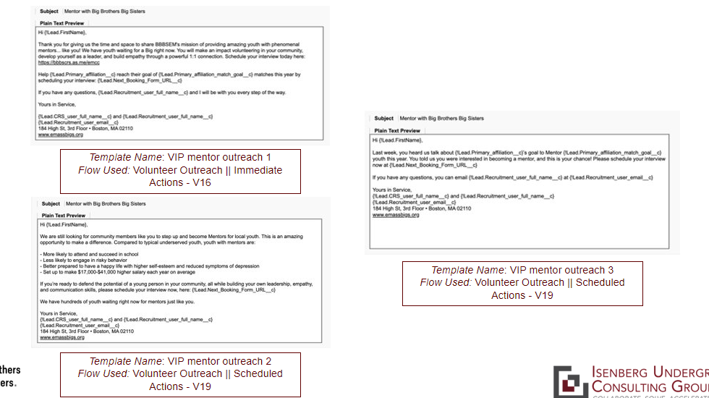

1. **Meredith:** Something that BBBSEM seems to place a lot of focus on Is utilizing data regarding volunteers within their communications workflows. Is this powerful? What’s the best way to make sure that the content is impactful in these emails?
   1. We, as consumers, are going through emails so quickly, that getting right to the matter as quickly as possible is of great importance. Our first step is to get people to open the email; then I’d advise making it short and simple as possible. MAKE IT ABOUT THE READER, THE POTENTIAL VOLUNTEER. Something like “BBBSEM is thrilled with the potential of working with you as a volunteer”; make THEM feel good. Then get to business; “To start this process, click here to schedule your interview”. Then make the last sentence really, really quick (“If you have questions, please reach out at ___”)
   2. We should make it so the reader can get through the content in 3 seconds. Usually, when people are looking at emails, they’re just scanning the material; try to cram impact in as short of time as possible.
   3. The email should *remind* you why you are excited to volunteer, but still should make them feel good.
   4. Content should depend a bit on the age of who you’re sending it too
      1. For college students/recent guides – make it short and sweet, like a text. ~90% of emails are read on phones, so we want to keep that in mind. “As short and compelling as possible”
2. **Meredith:** With regards to the email heading, all of them say “Mentor with Big Brothers Big Sisters” or “Thank You for your Interest in Big Brothers Big Sisters”. How would you go about making a subject heading that calls the reader into the email?
   1. Depending on their phone setup or how big the screen is, it’s possible that only 3 words are going to show; so something like “Thank you for your interest” might just show up as “Thank you for” - is that what we want to show? I think the choice for the heading depends on your goal.
   2. Starting the email with Thank You is always good, because it makes someone feel at least a bit accomplished. But I would say
3. **Spencer:** What about something like “Action Required”? Would that come off wrong with volunteers?
   1. First, I think you need to experiment to see what works. If the subject line was “Next step to becoming a Big Brother (or Sister)”, then it might incite a bit more urgency without mandating something to do. Through the title, it might be powerful to let readers know that *some* action is required!
      1. So look into that idea of “Next Steps”
   2. When the headline says something like “confirmation”, it might not incite action or next steps, so I’d be conscientious of that
4. **Meredith:** Throughout the communications, BBBSEM uses a lot of statistics or language along the lines of “We have so many children without mentors” or “Take a kid off of our waiting list”. In terms of best practices, is “guilt tripping” appropriate? Would it elicit a negative response?
   1. There’s an art and a science to this. It’s one thing if you’re sending out an email on Giving Tuesday, and you’re soliciting donations for a one-time action. What you’re asking people here is to enter into a relationship. So, the benefit of this is that there’s a *genuine need* – but you’re asking people to give their time/share their hearts. To me, this is about identifying the need to let the volunteer knows how much they’re needed, but also, we need to recognize that this is a pretty big ask. (Basically, we need to communicate this as a relationship rather than a one-time transaction).
   2. If I were you, I would go back to all of the “open rates” and see which ones were the highest. The rate might depend on factors like time of date, demographics, or other things, but it still can be interesting to **use the open rate as a measure of how compelling the language is**.
5. **Meredith:** So what I’m hearing is that we should keep these statistics and outcomes in the emails?
   1. I guess reading these, they’re a little wordy. We can make the language much more concise. The first few words are so important. I’d work on making the language as concise and compelling as possible. Try to work the statistics into the story.
6. **Spencer:** A lot of the Interview Confirmations are really long. They tell the person when their interview is, but *at the bottom of the email are forms that they need to fill out before the interview*. There are a lot of issues on the reader actually getting to these forms or remembering to hand these out. We are thinking of trying to bring these up the page as much as possible, and as a result, are curious if the video here is important?
   1. I think the video is like a **call to action for *someone who wants to sign up*. Once someone *actually* signs up, we need to work on making them actionable and prepared**. So in the subject heading, make it clear that the reader needs to do something *before* the interview. Also, move these forms up the screen! Not a horrible thing to have, but it should definitely be at the bottom of the email!
   2. Also, do these people *need to fill out the form in advance*? Or is it just a convenience for the organization. We basically want to consider how many “asks” we make before the interview takes place. If you’re going to ask someone to take action, just make sure things done in advance are very prioritized. For each thing you ask them to do, it takes more and more energy for the volunteer, which can make them second guess their desire to be involved.
7. **Meredith and Selvana:** In terms of if the forms are necessary – The Pre-Interview Questionnaire and Application are important in deeming if someone is “viable” as a volunteer. A small percentage of interested volunteers are deemed ineligible, but more so, they help to make sure people are prepared with the Background Check and have the Reference Forms. After they’re interviewed, there are no designated email flows – the communications are more sporadic and ad hoc. Should we recommend that the emails are more consistent and uniform? How can you keep people engaged over a period of time?
   1. Difficult question, especially because this does take a long time. The closest experience I have with this is when I worked in museums, recruiting docents for the museum (long time between hiring date and start date). What does help is scheduling 1-2 in-person events to remind these people of *why they’re there*. You can present it as a “pre-training”, with food and some alumni of the program.
   2. The other consideration is that this is the time where people get those inspirational video clips that are included in the Confirmation Emails. Giving them more information or statistics isn’t going to increase engagement. Fostering this emotional connection is that could really engage with people and remind them that this wait is for a good cause.
   3. Social media and inviting them to follow the organization on social media – they get a lot of media attention. If you can send these volunteers a link to the story, BBBSEM could capitalize on this publicity and remind the potential volunteers of the work that is done.
   4. Make all outreach as emotionally engaged as possible. Use social media, testimonials, and media attention to keep people engaged.
8. **Selvana:** How can we highlight impact while keeping emails short and concise (how can we highlight the impact in words)?
   1. I’m a fan of “Showing rather than telling”. I’d add articles and other media to these emails to *show* people that there is impact in the work.
   2. Keep engagement genuine, fresh, and surprising
9. **Spencer:** One difference between your experience with the museum and our organization is that during that wait, someone *isn’t even confirmed* to be a mentor; do you think that these will be impactful if someone isn’t guaranteed a position with BBBSEM?
   1. Well, it depends how you frame it. Perhaps you can frame it at a “*Bonus Training”*. You don’t get the *actual* training til you’re accepted, but it can still add value to those who will become a mentor.
   2. A lot of times, people volunteer because they’re lonely. Introducing these volunteers to each other could add a point of connection with these people
10. **Spencer:** Do you think that this training should be provided by BBBSEM? Could it be something like a TEDTalk on the topic? Something that’s not specific to the organization that would still be of value here?
    1. I think whenever there’s vetted, 3rd party content, then it can be beneficial. You can include these materials as a link or in-person, it *would just have to be something of value to the readers*. My guess is that people may drift off just because of time; adding in a sense of fun or connection with others in an interesting, unique way would also be helpful
11. **Sankalp**: I am focusing more on the marketing and recruiting funnels. If we could go to Slide 26, we can see some of the advertisements that are distributed via Social Media. Are these posts good? What’s your feedback?
    1. 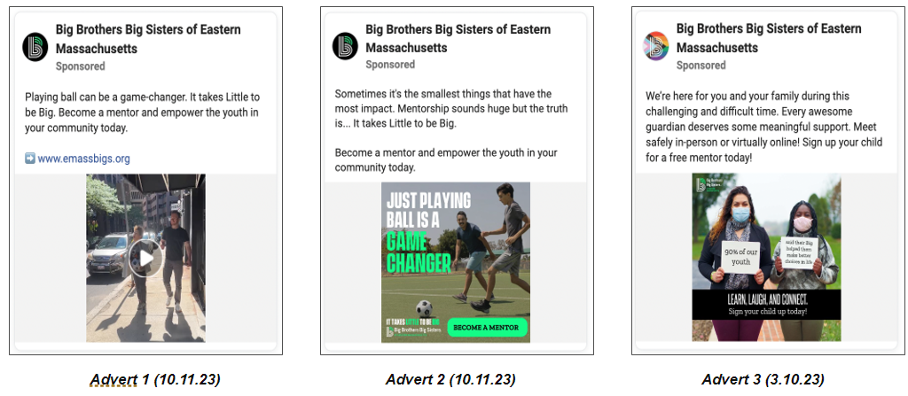
    2. **Try to keep these in 1 sentence**; the 3rd one especially is a bit long.
    3. There also can be some confusion on the lingo – *what is a big? What is a little?* When doing social media outreach, you need to know that the target audience may not be familiar with all the language.
    4. The “empower the youth in your community today” is super vague. We need to capture how BBBSEM is *changing someone’s life*. The mentors can *change the trajectory* of someone’s life. We can’t overpromise, but we definitely want to remind people of *why they might be interested in volunteering*.
12. **Sankalp**: The recruitment fliers in Slide 27 also describe a bit of the program to potential volunteers, except this targets more of a working audience. What are your thoughts on this?
    1. 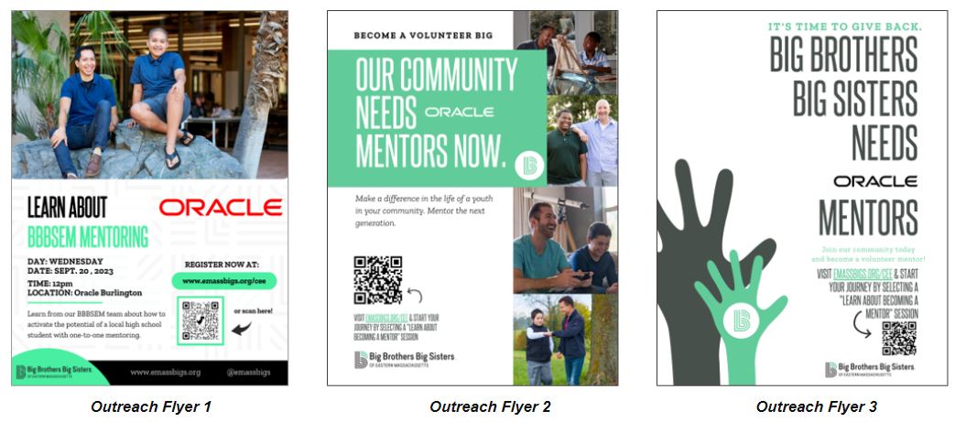
    2. There’s a lot of text; lots of it and its very very wordy
    3. The arrows are a bit confusing
    4. Ideally with an ad, you should be able to tell what it is without reading anything. Can you tell what this ad is asking with no text?